
THE PRIORY PRIMARY SCHOOL SAFEGUARDING TEAM
School Contact Details
The Priory Primary School, Pamber End, Tadley, RG26 5QD
01256 850062. office.tpps@sfet.org.uk
If you are worried about a child, speak to one of the safeguarding team immediately.
Never promise confidentiality. Record concerns and report them straight away.
  Debra Adams  DSL & Deputy Headteacher  dadams@sfet.org.uk |   Matt Walsh  Headteacher & DDSL  mwalsh@sfet.org.uk
  Angela Selwood  SENDCo & DDSL  aselwood@sfet.org.uk | 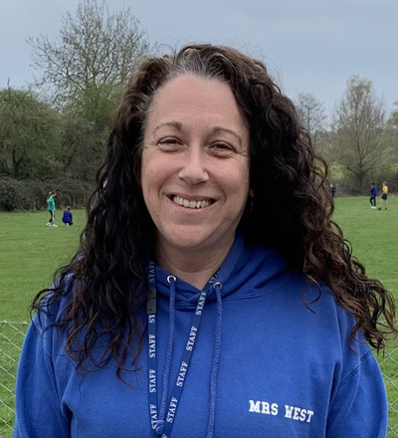  Su West  ELSA & DDSL  swest@sfet.org.uk

What to do if you are worried about a child
Listen carefully and remain calm. Reassure the child that they have done the right thing by speaking up. Make a factual written record of what you observed or were told. Report your concern immediately to the DSL or a DDSL.
If a child is at immediate risk of harm, call 999 to seek urgent assistance and inform safeguarding leads without delay.

Report a concern to Hampshire’s Safeguarding Children Partnership
https://www.hampshirescp.org.uk/report-a-concern/
Worried about yourself, a friend or a child or young person you know?
You do not need to know everything about the child before contacting Children’s Services. If you are concerned, it is important that you talk to someone about this.
Hampshire Children’s Services
Members of the public
If you are a member of the public and wish to report any welfare/safeguarding concerns, please complete the online safeguarding form or:
Telephone: 0300 555 1384
Out of hours: 0300 555 1373

