
THE PRIORY PRIMARY SCHOOL SAFEGUARDING TEAM
School Contact Details
The Priory Primary School, Pamber End, Tadley, RG26 5QD
01256 850062. office.tpps@sfet.org.uk
If you are worried about a child, speak to one of the safeguarding team immediately.
Never promise confidentiality. Record concerns and report them straight away.
  Debra Adams  DSL & Deputy Headteacher  dadams@sfet.org.uk |   Matt Walsh  Headteacher & DDSL  mwalsh@sfet.org.uk
  Angela Selwood  SENDCo & DDSL  aselwood@sfet.org.uk | 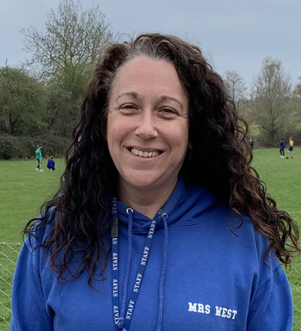  Su West  ELSA & DDSL  swest@sfet.org.uk

What to do if you are worried about a child
Listen carefully and remain calm. Reassure the child that they have done the right thing by speaking up. Make a factual written record of what you observed or were told. Report your concern immediately to the DSL or a DDSL.
If a child is at immediate risk of harm, call 999 to seek urgent assistance and inform safeguarding leads without delay.

