Friday 6th March 2026

Dear Parents and Carers,
My Child at School (MCAS)

We’re excited to introduce My Child at School (MCAS), a new platform for parents and carers. MCAS will become our main system for communication, trips, club and lunch bookings, replacing the current Arbor system. MCAS is the parent app that runs alongside our new Management Information System (MIS), Bromcom. We have been using Bromcom in the school for this week and it’s all gone well. The MCAS App will hopefully feel like an upgrade from the Arbor App. It’s very user friendly and is a one-stop-shop, which we’ll increasingly use for parent-school interactions.

Account Activation

You will receive an activation email this evening (if you haven’t done already), which contains a link to set a password for your MCAS account. MCAS can be accessed via web browser on a computer, or you can download the app for use on a mobile phone.

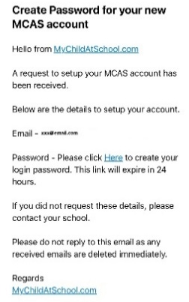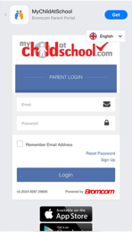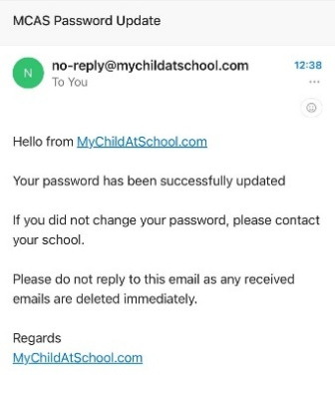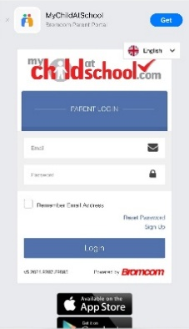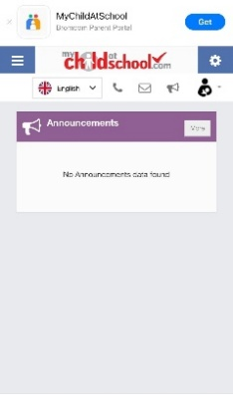

After setting your password, you will be able to log in and access your MCAS account. If you have multiple children at The Priory Primary School, you will be able to see each child individually by selecting them from the dashboard on the left-hand side (or at the top on the phone app).

IMPORTANT: Please ensure you enable push notifications on the app.
It is very important that you do this, as this allows the school to keep you updated with all communications via the mobile phone app.

If you have not received your activation email by Monday 9th March, please contact the school office.

MCAS Account

Once you have signed up to the MCAS app, you will be able to start familiarising yourself with some of the features. The following changes to daily routines will occur over the coming term:
- We will be sending out all school communication through the MCAS app, as well as more direct messages from teachers on Dojo, as we do currently. You will receive a digital notification from the app (as long as you enable push notifications) to help you to instantly be kept up to date with the communication from the school.
- You will also be able to update your child’s details and permissions via the app.
- Please take the opportunity to check that your child’s medical information held by the school is correct. This can be done by clicking on the data collection form and scrolling down to the bottom.

CLUBS:
- You will be able to see the Clubs button within the app, and within this, you will be able to see
  - which clubs are available to your child (including whether or not the club has space),
  - which clubs your child is already enrolled in (from Arbor, n.b. this will not include Gardening Club, Petite Dance Club or Gol Football) and
  - the clubs for which your child is on the waiting list.

- Each club listed, has a “view detail” button, if you click through, you will be able to see spaces available, times and date of next session. Here, there will be a button at the bottom which says “Add to Waiting List”, if required.
- Please note that the prices shown on the current clubs, reflect the 3 weeks remaining of this term. You are able to book via MCAS for the last 3 weeks.
- Similarly, when clubs become available for next term, there will be one price showing for the first half of term. Please note, that if you do not book at the beginning of the term, and you would like to join during the term, you will need to email or call the school office, and we will book your child on for you, and raise the order to pay on your MCAS.
- The app will provide you a notification once the clubs sign up is live.

LUNCH BOOKINGS AND PAYMENTS
- You will see the “Dinner” button on your MCAS.
- You will be able to flick through each week until the end of term and see the menu options for each day.
- You will also be able to order your child’s lunch - a whole half term in advance if you prefer!
- Click on to a specific day, and then click the drop down for “Spring Term Menu 2026”, and it will show you the options. You highlight the option of your choosing, then click submit – and your child’s lunch is ordered. You can cancel selection if you’ve made an error.
- N.B. Parents will not be able to order their child a lunch, without first “Adding Dinner Money” to your account – a button for this is at the bottom of the weekly menu.
- No child will ever go hungry, but this new system, from next week, is set up for prepayment.
- If your child has had a lunch this week at school, it will show on their account when you log in.

TRIPS: These will be live on MCAS soon. We will communicate clear instructions when a new trip is added. We will also be migrating over the current trips you’re child is currently signed up for on Arbor.
ATTENDANCE: You will be able to see your child’s attendance record
PARENTS EVENING: These will be visible in time to book your next parents evening in Autumn 2026.
REPORTS: You were sent your child’s mid-year report from Arbor, but any further reports, e.g. End of Year Report, will show within this button on MCAS.
DATA COLLECTION: Please check your data in this section and change what you’re able to change. If there’s anything incorrect, but you’re not able to change it, please email the office.
PARENTAL CONSENT: Previous parental consents will not show here, but future ones will.

We are very excited to be moving to MCAS and the new opportunities this offers in streamlining our communication, payments and student records into one place.
Please take your time to familiarise yourself with the app. We hope you’ll agree that it is a very user-friendly set-up.
Yours sincerely,

Mr Matt Walsh

Headteacher

